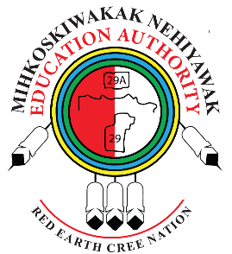
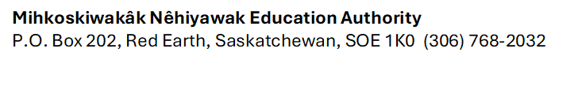MNEA Community Newsletter
Issue: August 2025 Mihkoskiwakâk Nêhiyawak Education Authority | Red Earth Cree Nation
🌿 Honoring Our Roots, Inspiring Our Future
At Mihkoskiwakâk Nêhiyawak Education Authority (MNEA), we are proud to walk alongside our students, families, Elders, Knowledge Keepers and educators on a journey grounded in the Nêhiyawak worldview. Education is more than academics—it is a sacred path that nurtures identity, belonging, and lifelong learning.
🧠 Our Educational Philosophy
We believe that every child carries gifts from our God. Our role is to help them discover and develop those gifts in a safe, inclusive, and culturally rich environment. Our guiding principles:
- Cree Language & Culture First: Language is the heart of identity. We embed Cree teachings in every classroom.
- Inclusive Education: Every learner is valued. We support diverse needs and celebrate all abilities.
- Land-Based Learning: The land is our first teacher. Students engage with nature to learn traditional knowledge and stewardship.
- Community Connection: Families, Elders, and educators work together to uplift our children.
📣 School Year Announcement
Student Registration will begin on Friday August 29th 9:00 – 12:00 pm.
We’re excited to announce that the MNEA 2025–2026 School Year will officially begin following Labour Day weekend! We look forward to welcoming students back into a vibrant learning space that reflects our values, traditions, and commitment to excellence.

🧭 Staff Orientation Week: August 25–29
MNEA education staff will be participating in Orientation Week from August 25 to 29 in preparation for the upcoming school year. This important week will focus on collaborative planning, cultural grounding, and professional development to ensure a strong and unified start to the 2025–2026 academic year. We look forward to reconnecting, sharing knowledge, and setting the tone for a successful year ahead
📌 Stay Connected
Visit our website for updates, employment opportunities, and upcoming events: 🌐 www.recned.ca
Follow us on our school facebook page to see highlights from our classrooms, cultural activities, and student achievements.
🏫 School Contacts
For questions, registration, or support, please contact your child’s school directly:
School Name | Contact Person | Phone Number
Mamawe Awasis Elementary School | Principal Lydia McKay | (306) 768-3544
John William Head Memorial Education Centre | Principal Barry Whitehead | (306) 768-3654
MNEA Main Office | Lenore Henderson | (306) 768-2032

💬 Final Thoughts
As we prepare for another school year, we give thanks to our Elders, our families, and our community for their continued support. MNEA remains committed to nurturing the next generation of Nêhiyawak leaders, thinkers, and knowledge keepers.
Miyopimâtisiwin—Live a good life.
Ekosi Pitima

